
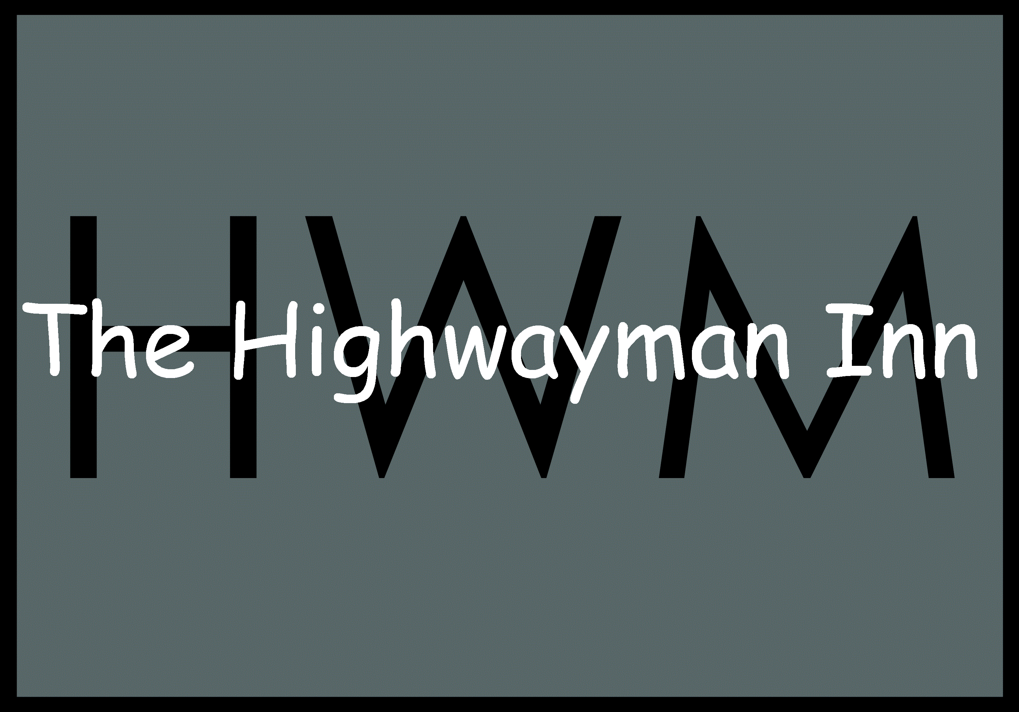
Highwayman Christmas Luncheon menu
£32 for 2 courses
£37 for 3 courses

*Broccoli and Oxford blue cheese soup with croutons

*Chicken liver parfait, cranberry sauce butter, toasted bread

*Beetroot cured salmon, horseradish cream, lemon gel, micro leaf salad

~~
*Highwayman roasted turkey,
roasted potatoes, honey roast carrots and parsnips, Brussel sprouts, chestnut, pigs in blanket, cauliflower cheese, jus and homemade cranberry sauce (N)

*Herb crusted hake, Chantenay carrots, tenderstem broccoli, hassleback potatoes, moules bouillabaisse

*Highwayman bubble and squeak, roasted roots, wild mushrooms, spinach, fried hens’ egg, hollandaise sauce

~~
*Christmas pudding, brandy anglaise

Salted caramel cheesecake, gingerbread man

Roasted fig and orange frangipane tart, mascarpone and honey

~~
Mince pies
A 12.5% service charge will be added.
All our dishes are cooked to order. Please be patient during busy periods.
Make us aware of any allergies and ask for further details of dishes that contain allergens
(N) contains nuts. (*)- Can be Gluten Free

