
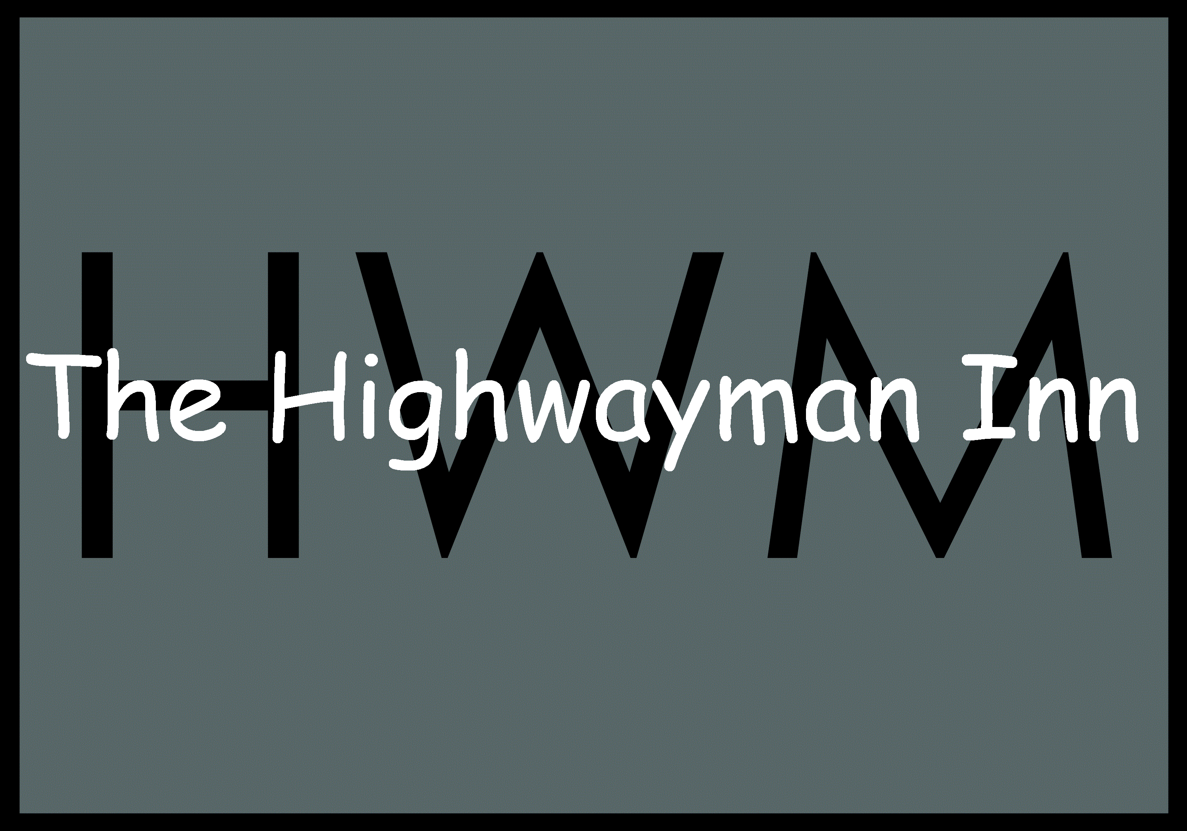
Highwayman Christmas Dinner menu 2026
£43 for 2 courses
£48 for 3 courses

STARTERS
*Broccoli and oxford blue cheese soup with croutons

*Chicken liver parfait, cranberry sauce butter, toasted bread

Tempura king prawn, kimchi, coriander, cucumber and dill salsa

Slow cooked lamb bon bons, redcurrant reduction, watercress, rosemary curd

*Grilled haloumi, Mediterranean vegetable tian, pimento and Sakura

MAINS
*Highwayman roasted turkey,
roasted potatoes, honey roast carrots and parsnips, Brussel sprouts, chestnuts,
pigs in blanket, cauliflower cheese, jus and homemade cranberry sauce (N)

*Pan fried fillet of John Dory, creamy mashed potato, fine bean and leek bundle, baby carrots, scallops, grape, tomato and garlic salsa, infused truffle beurre blanc

*Roast Gressingham duck breast, cavolo nero, spiced walnut braised red cabbage, dauphinoise potato, blackberry jus

*Soy honey and sesame salmon, aromatic rice, pak choi, tenderstem broccoli, sweet and sour cabbage

Goats cheese Wellington, mixed wild mushrooms, spinach and butternut squash, parmesan paprika cream sauce

PUDDINGS

*Highwayman Christmas pudding, brandy anglaise

*Chocolate torte, winter berry meringue

*Pistachio brûlée, fresh raspberries and biscotti

Roasted fig and orange frangipane tart, mascarpone and honey

Salted caramel cheesecake, gingerbread man
~~~~~~~~~

Mince pies
All our dishes are cooked to order. Please be patient during busy periods. Make us aware of any allergies and ask for further details of dishes that contain allergens
(N) contains nuts (*)- Can be Gluten Free. A 12.5% service charge will be also added.

