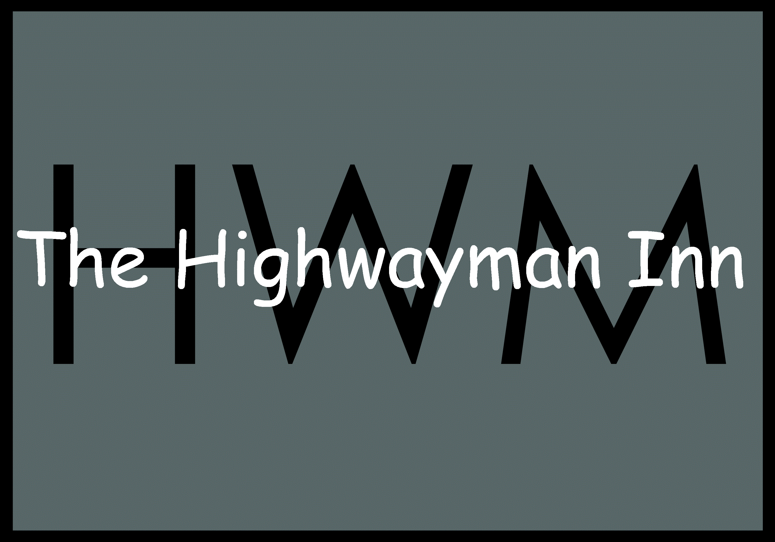

Saturday 27th July
9 am -11 am

Breakfast menu

The Dick Turpin breakfast
Cumberland sausage, Crispy bacon, black pudding, baked beans, hash brown, grilled tomato, mushrooms, eggs (scrambled, poached or fried) and toast £13.50

Children’s Highwayman (12 and under) sausage, bacon, hash brown, beans, toast and an egg £7.50

The Bessie Turpin
Smashed avocado, bacon or halloumi, 2 poached eggs, tomato salsa on toast £10.00

The Dippy Egg
boiled egg with marmite on toast £5.00

bookings advisable 01491 682020, enquiries@thehighwayman-inn.co.uk

